In this short mat time activity, I have chosen to read the children book Finding Swell. This book will be a great asset for teaching my Year 1 students how to compare different kinds of images in narrative and informative texts and discuss how they contribute to meaning. This is a Year 1 English curriculum link for literacy (ACELA1453). All students will be encouraged to respond and be engaged during this activity. Students will sit in front of the educator in a half moon shape to be able to listen, see and participate in the reading of Finding Swell and the mat time activity.

Let me show you step by step how this activity will go!

First read Finding Swell.

Then go back to page one in the book Finding Swell,
Reread “How can I surf if there are no waves? How unpredictable the ocean can behave.” Show image of first page in the book to the students.

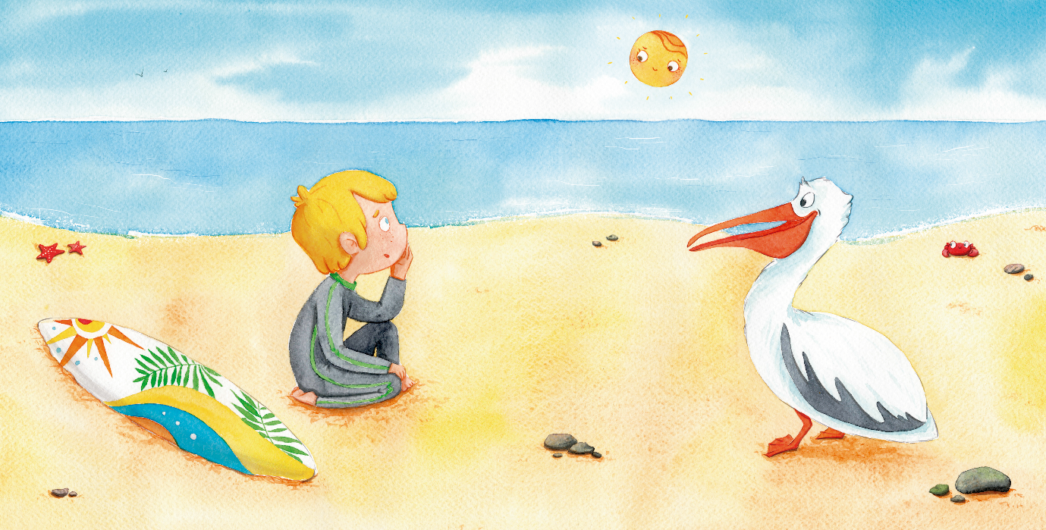

Ask: If we look at the picture of the boy looking at the ocean and then read what the boy is thinking, what is the book trying to tell us? Allow students to answer
Teacher answers: That the waves are too small to surf. This we can visually see – Allow students to explain why
What can we not see? We cannot see the boy surfing, but the text tells us he wants to. Can we imagine him surfing?
Ask: What is surfing? What does someone need to surf?
Can the boy surf the waves on this page (18)?
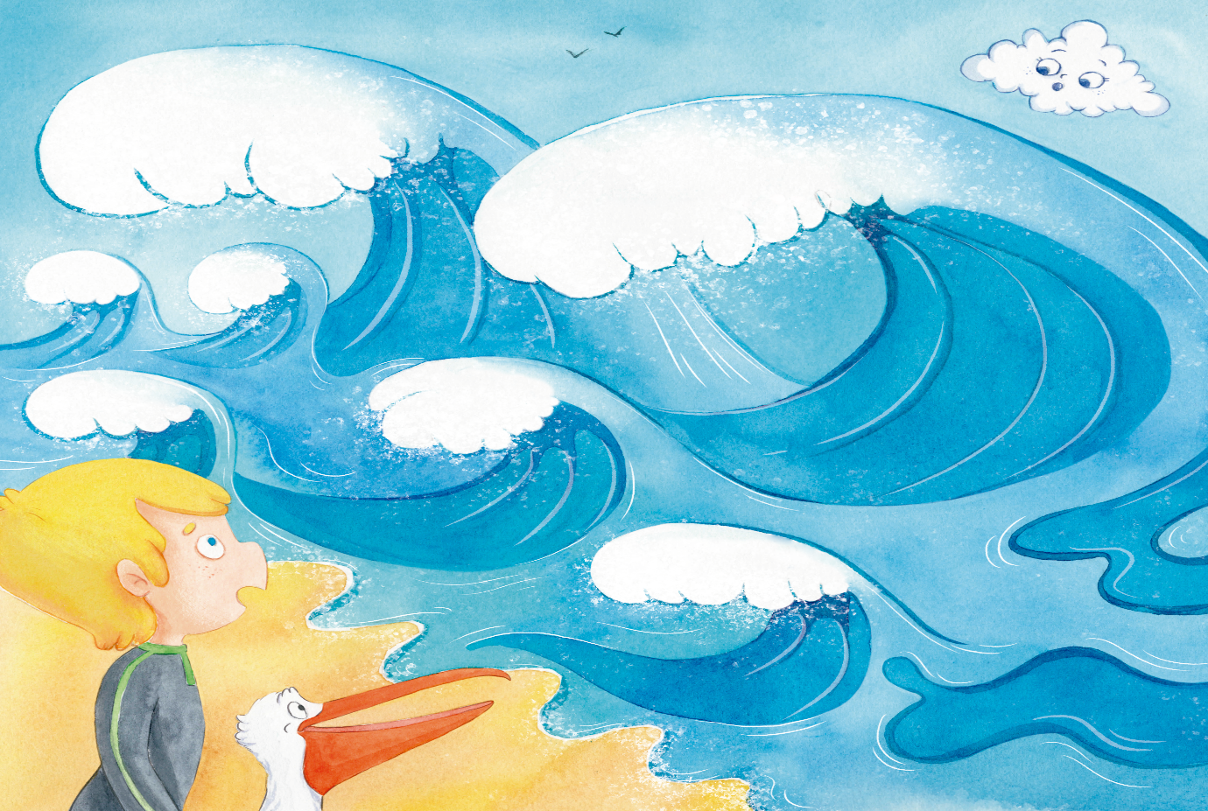

Does the boy decide to surf these waves? Allow students to answer

Linking meaning to text
Let’s talk about why we call surfing, surfing.
Surf means the swell of the sea that brakes upon the shore (Merriam-Webster, 2020). Surfing is riding that swell or wave that brakes upon the shore (Merriam- Webster, 2020).
____

The reason why I chose Finding Swell is because my students live on the Central Coast of NSW. Although everyone does not surf it is still a big part of the culture here. Flint (2016) believes that readers will not engage with the text if they do not connect or make sense of the text. By choosing a topic that is popular within the culture, students will be more inclined to be engaged during this activity as well as have prior knowledge about the content. Harvey (Silver et al, 2007) notes that if the educator can design content that bridges students to connect to past knowledge and also build new connections to new knowledge, learners will be able to link their ideas to the current and future content being taught. Meaning, the educator must make a principal connection. If the educator, such as myself, is able to connect new information to a clear purpose along with student’s prior knowledge, the easier it will be to prime students’ memories as well as keep their attention (Silver et al, 2007). In this case, students are decoding the text as well as decoding the illustration and determining what is real and what is imaginative. Both the text and the illustration are telling the student that there are no waves to surf on, but what does that mean? Do the students understand why the boy cannot surf? This is where my principal connection comes in and links meaning to the illustration and text by first getting the students to imagine the boy surfing and then by defining what surf and surfing actually is. When students are able to understand that a flat ocean is un-surfable then they can start to imagine and predict what lies ahead in the story. In this case, Swell or surfable waves. It is considered that I am using what is known as a psycholinguistic theory during this mat activity. For I am trying to get students to be able to construct meaning from the text as a whole where I, the educator, can then focus on smaller targeted pieces of text to describe what is ‘real’ in the text and what can be ‘imagined’ in the text (Flint, 2016).

Now go to page ten, the boy notices a mist of spray coming from the ocean. Show the image in the book.

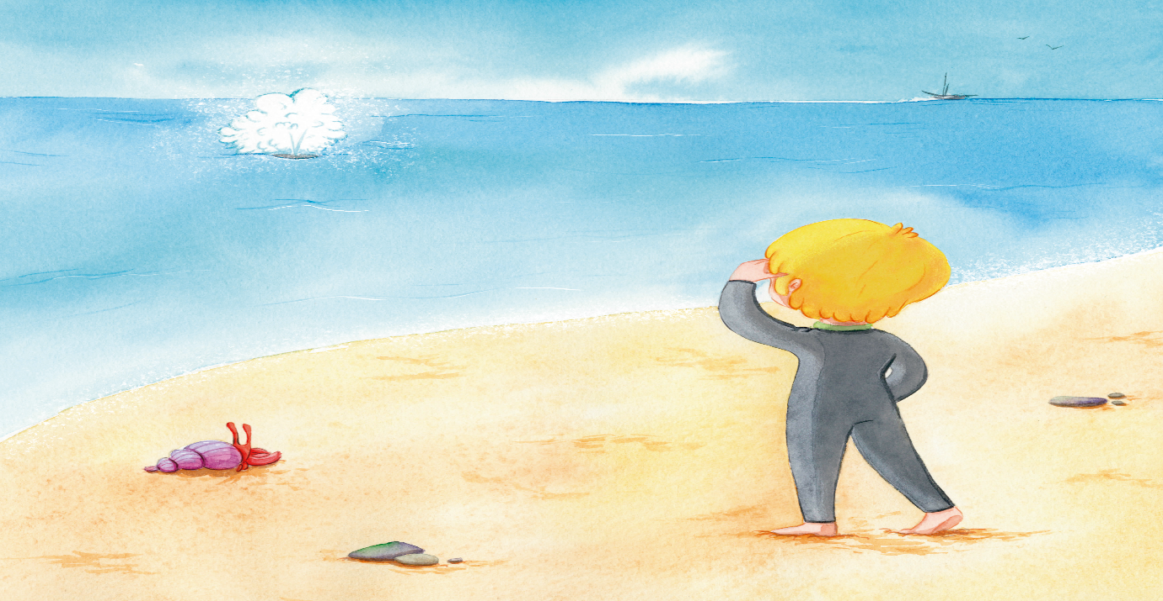

Ask: Before finding out who’s mist was coming from the ocean, what were your thoughts or predictions of what animal might have been making the mist? Allow students to answer
Explain: The picture and the text here didn’t give us enough information to know exactly which animal it was, but it did allow us to imagine which animal it could have been. This made us want to keep reading, didn’t it?

Ask: The boy mentions that the mist is coming out of a spout. From the picture and the words used in the book who might know what a spout is? Why might an animal need a spout?

Linking meaning to text
A Spout means to discharge or empty a liquid or other substance continuously or in spurts.

When looking at the next illustration we discover that it is a dolphin that is creating the mist.
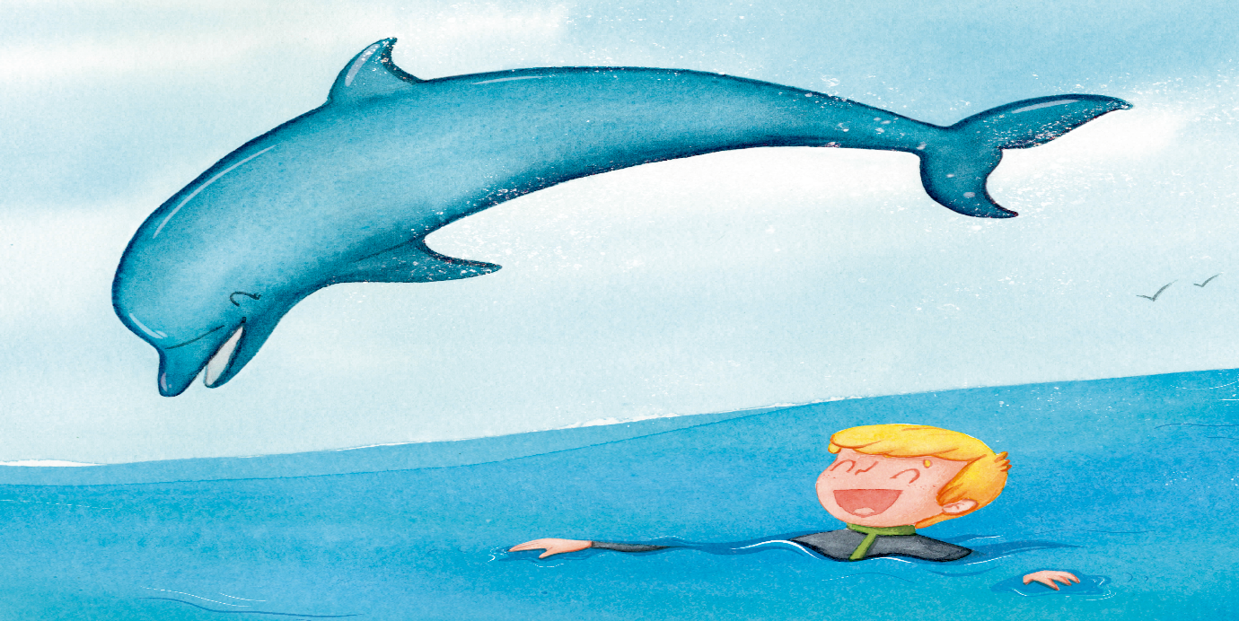

Is the dolphin really spitting water out?
Explain: A dolphin is actually exhaling or emptying old air out of its lungs through its spout. Right before the dolphin blows out the old air it is heated by the lungs and some of the air is moist. When the moist warm air reaches outside from the spouting dolphin that air becomes a vapor which is what you see coming from the dolphin (Whalesbermuda, 2012).

What is another name for a spout when thinking of a dolphin? The spouts proper name when talking about animals is called a blowhole

What kind of animals that live in the ocean have blowholes or spouts? Are these the animals we imagined before we knew it was a dolphin?
____

Throughout our mat activity I am continuously trying to focus on our curriculum link which is comparing different kinds of images in narrative and informative texts and discuss how they contribute to meaning. The text and the illustration do not give us enough information to know what animal is creating the mist. I then allow the students to talk and express their thoughts and ideas to the class. Evidence shows that allowing this type of activity where students have opportunities to respond to text in a social environment actively supports their thinking, talking and writing (Flint, 2016). This is a strategy derived from what is known as transactional theory. Langer (1995) notes, that allowing students to talk about their thoughts and ideas within the classroom allows others students to view into each other’s minds which allows students to envision their peers personal and cultural past experiences. This gives diversity and different ideas to the content being discussed. By doing so, I am able to see which students understand what types of animals that live in the ocean are able to create such a mist. I then move along to link spout to blowhole through definitions and meaning in an attempt to create new knowledge for my students.

The purpose of using a whole class discussion during this mat activity is to enhance my student’s knowledge and understanding of how to participate in such a social event (Killen, 2013). Bridges (1990) suggests that students need to be taught certain moral dispositions, such as the willingness to listen and abide by rules that help facilitate the exchanges of ideas within a classroom discussion. As the educator, I am continuously modelling such behaviour as well as presenting information using auditory, visual, emotive and kinesthetic cues to make information come to life as well as memorable for the students (Silver et al, 2007). This keeps my students engaged and actively responding throughout this mat time activity.

On page 23 and 24, show the image in the book.
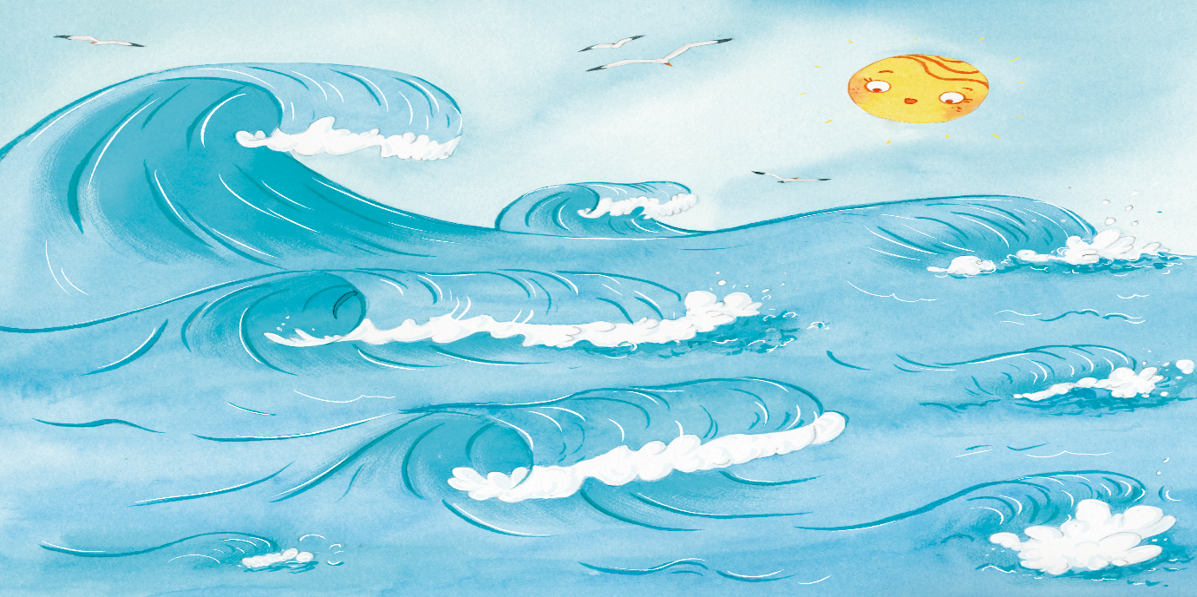

Ask: What is the text telling us? Allow students to answer
What text gave us this answer? Allow students to answer
Answer: That surfable waves have arrived. The text is telling us that Dolphin has finally brought his friend Swell so the boy can surf. Can we imagine the boy surfing these waves? Talk about surf slang words (ie, mile-long face)
What is swell? Allow students to answer

Linking meaning to Text

Explain: A swell is a series of waves generated by distant weather systems that travel thousands of miles across oceans and seas (SurferToday, 2020).

Ask: Is a wave and a swell the same? Allow students to answer

Explain: Waves can be created by anything like boats, wind or even your hand. Swells are specific types of waves that are created by storms that travel long distances.

Can we imagine all the different types of waves that the boy experienced today?

End on talking about beach and ocean safety. Recognise situations and opportunities to promote health, safety and wellbeing (ACPPS018). Allow students to discuss

____

Lastly, I chose to focus on this body of text to bring the mat activity full circle by talking about the description of the waves the boy and his friends were able to surf. This allows an opportunity for the educator to introduce an important subject for Year 1 students and that is water safety. For Year 1 students, the Australian Curriculum [ACARA] (n.d.) emphasizes the importance of students being able to identify, recognise and perform actions to stay safe in an environment around water (ACPPS018). Here, the educator can allow Vygotsky’s social constructivist theory to shape students cognitive development by allowing students to draw upon each other’s knowledge about water and beach safety when participating in this class discussion (Duchesne & McMaugh, 2018). Water safety happens to falls under the category of Health and Physical Education. This means I have successfully linked cross curriculum learning to my students. This is an essential skill for students to learn where students are able to transfer knowledge and skills throughout different subjects (Cross-Curriculum Teaching, 2008). This also allows the me, the educator to identify which students are able to perform this skill and make anecdotal notes for future lesson.

Review

This mat activity is centred on an inclusive classroom approach where the topic is cross-cultural, the application of strategies used does not prevent exclusion and the use of strategies to increase student participation is based on the latest research (Gardener, 2002).

The main focus throughout this mat activity was to allow students to practise their use of oral language. Making meaningful use of oral and written language is the context for reading and writing which is known to improve literacy development (Teale & Sulzby, 1986).

By reading Finding Swell fluently before stopping and asking questions allowed me to model and contribute to my students reading comprehension, influencing them to become capable readers themselves (Teale & Yokota, 2000).

Using a psycholinguistic theory with strategies that encourage classroom discussions has allowed me to use a student-centred approach to this literacy learning activity (Flint, 2016).

Using transactional theory strategies within this activity encouraged my students to negotiate through their own background experiences and knowledge that contributed in making meaning of the text and illustrations discussed in class (Flint, 2016).

References
Australian Curriculum Assessment and Reporting Authority [ACARA]. (n. d.). The Australian Curriculum: Health and Physical Education. http://www.australiancurriculum.edu.au/download/f10

Berry, W. (2019). Finding Swell. InHouse Print & Design.

Bridges, D. (1990). The character of discussion: A focus on students. In W. Wilen (ed.), Teaching and learning through discussion (pp. 97– 112). Thomas.

Cross-Curriculum Teaching. (2008). Teachers TV/UK Department of Education. Alexander Street. Brook Lapping Productions. https://video-alexanderstreet- com.dbgw.lis.curtin.edu.au/watch/cross-curriculum-teaching
Duchesne, S., & McMaugh, A. (2018). Educational Psychology for Learning and Teaching (6th Ed.). Cengage. Chapter 10 Cognitive Explanations of Learning.

Flint, A. (2016). Literacy in Australia: Pedagogies for Engagement. Wiley.

Gardner, P. (2002) Strategies and Resources for Teaching and Learning in Inclusive Classrooms. David Fulton.
Killen, R. (2013). Effective teaching strategies: Lessons from research and practice. (6th ed.). Cengage Learning Australia

Langer, J. A. (1995). Envisioning literature: Literary understanding and literature instruction. Teachers College Press.

Merriam-Webster. (2020). Surf. Merriam-Webster. https://www.merriam- webster.com/dictionary/surf

Silver, H., Strong, R., Perini, M. (2007). The Strategic Teacher: Selecting the Right Research-Based Strategy for Everyone. Association for Supervision & Curriculum Development.

SurferToday. (2020). What is a Swell. SurferToday. https://www.surfertoday.com/surfing/what-is-a-swell

Teale, W & Sulzby, E. (1986). Emergent Literacy: Writing and Reading. Ablex Publish Corp.

Teale, W., & Yokota, J. (2000). Beginning reading and writing: Perspectives on instruction. In D. Strickland & L. Morrow (Eds), Beginning reading and writing (pp. 3– 21). Newark, DE: International Reading Association.

Whalesbermuda. (2012). How does a whale use it’s blowhole. WhalesBermuda. https://www.whalesbermuda.com/all-about-humpbacks/faq/31-faqs/199-how-does-a- whale-use-its-blowhole

